Background: Must Farm - The end of the settlement
Must Farm was a small group of nine houses. We don’t know exactly how many people would have lived there but it might have been one big extended family. Imagine living in a small village with all your Aunts, Uncles and cousin as well as parents and grandparents.
We know that the houses burnt down because of all the burnt wood found by the archaeologists. What we don’t know yet is why it burnt down. All of the houses would have had a fire inside so it’s possible that it was an accident.
This isn’t the most likely explanation as the whole village was built over a river and everything would have been quite damp so the fire wouldn’t have started from just one spark from a fire. The archaeologists from Must Farm are working with a fire investigator who is trying to work out how the fire started and spread and at the moment they think that it was maybe started deliberately. Their ideas might change as they look at all of the evidence but at the moment that is the most likely reason.
It looks as though everyone escaped the village safely as no bodies were found. Could it be that everyone was somewhere else when it was burnt down? Did the fire burn slowly enough that everyone could get out before it got too bad? Lots of things were left behind in the houses so people must have decided that it was burning quickly enough for them to leave all of this.
The archaeologists think that the village had probably only been built a few months before it burnt down so lots of work went up in smoke after a very short time. Can you imagine what it would feel like to stand and watch this happen?

Imagine what happened to change this | to this
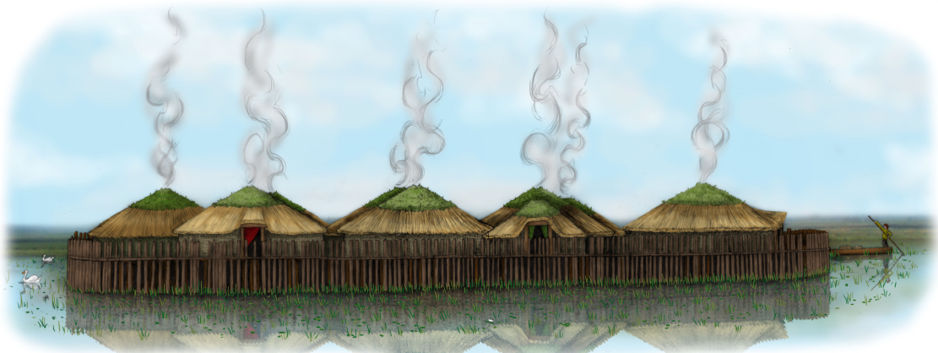 | 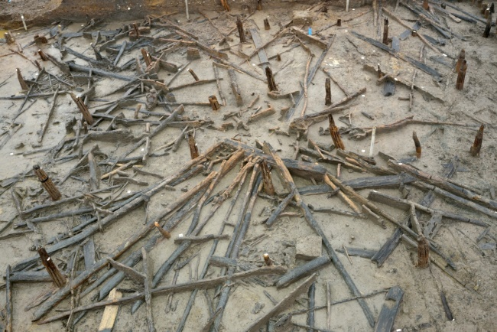

Challenge: Plan and write a story imagining that you were one of the people who lived at Must Farm.
Plot

- What’s going to happen? Most stories (but not all!) have:
- A set up or opening- setting the scene and introducing characters
- A build up
- A problem to solve
- A resolution- the problem is solved
- The ending

Plan your story here:

Setting the scene
Think about the evidence about life at Must Farm. What might you be doing? Children would have had work to do and you might have been getting ready to walk to fields nearby to look after crops growing or maybe learning to make pots, spinning, weaving or looking after animals? Brothers, sisters and cousins would have all been around and maybe your story would have them in too.

My characters
What they were all doing at the start of the story
The build up
How did you find out about the fire? Were you all inside the village or did you see smoke from far away? Think about sounds and smells to include in your story

A problem to solve
Oh no! There is a big problem! It’s bad enough that the houses are on fire but something else is going wrong- what could it be?

The resolution
The problem is solved- who solves it? Do they use any of the objects found at Must Farm that you have learnt about? What do they do?

The ending
The houses have burnt down, the big problem has been solved but what do you and the other characters do next? Where do you think the people who lived at Must Farm went?

This activity is designed to be used alongside the other resources relating to Must Farm found at:
https://historicengland.org.uk/services-skills/education/teaching-activities/must-farm-life-in-bronze-age-cambridgeshire

