Migratory History of Bradford

This timeline of Bradford`s migratory history includes reference to:
- Regional migration within Great Britain e.g. from Devon or Scotland to Yorkshire (the first nineteenth century mayor of Bradford was a Scottish merchant)

- Migration within the British Isles e.g. from Ireland to Great Britain (Irish migrant workers lived in some of Bradford's worst slums during the cities' industrial expansion)

- Migration from outside the British Isles e.g. from Germany or South Asia (Germans and German Jews helped to build up Victorian Trade and Pakistani workers helped keep declining textile mills open in the 1960s and 1970s)

Date | What was happening in Bradford
1773 | The Piece Hall was built to display and market locally produced cloth. It attracted further trade to Bradford`s growing textile industry.
1774 | Bradford canal was opened.
1780 | Bradford was a small market town with a population of 4500.
1788 | Bolling Ironworks was founded.
1791 | Low Moor Ironworks was founded.
1800 | Holme Mill, Bradford's first steam powered textile mill was founded.  A few Irish workers started arriving in Bradford looking for work.
1801 | Bradford was an expanding market town with a population of 13,264.
1805 | Iron cannon forged in Bradford were fired on board British warships at the Battle of Trafalgar fighting the French emperor Napoleon.
1819 | An Irish clergyman Rev Patrick Bronte moved in to what is now Bronte Parsonage in Haworth with his family including his daughters, Charlotte, Emily and Anne who became famous writers.
1821 | Bradford’s population was 26,309.
1822 | Power looms to go in for Warbrick's Mill in Shipley were destroyed by workers frightened of losing their jobs.
1824-5 | Saint Mary's Catholic Church was built, the first in Bradford, largely for the benefit of Catholic Irish migrants who moved to Bradford to find work.
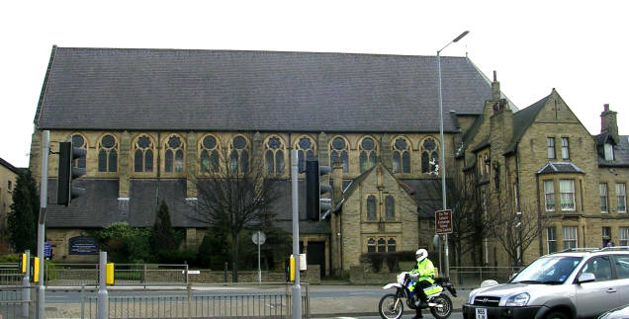
The former St Mary`s Roman Catholic Church on its second site Photo Credit; Betty Longbottom

1826 | Rioting unemployed workmen attempted to break up power looms installed in a mill. Two rioters were shot dead.
1829 | The first German Cotton merchant, Leo Shuster, settled in Bradford.
1831 | Bradford’s population was 43,527.
1830s | The Bradford Observer regularly filled its pages with Irish jokes. More Irish people came to Bradford in the 1830s and 40s than either before or afterwards. Most settlers were poor people from counties Mayo and Sligo. 75% could not read or write English and a third could not speak it. They were mostly forced to live close together in unhealthy slums in a small quarter of Bradford. There was lots of violence and drinking of alcohol like beer. Some people got drunk. Irish workers were could not get work in the mills. Irish people could only get the worst, most badly paid jobs.
1832 | Bradford elected its first MP.
1834 | Bradford had 34 steam powered textile mills.
1835 | Reverend Jonathan Glynde, Minister at Horton Lane Congregational Chapel reported "The natives of Scotland are here, the natives of Ireland are here, from the pleasant vales of Devonshire men and women have come: from the banks of the Rhine and the Elbe they are coming".
1837 | A crowd of 5000 people attacked Bradford Courthouse, protesting against the new Poor Law (this made workhouses for poor people who needed help really harsh places). There was and to hand fighting occurred between rioters and soldiers.
1837 | Eight foreign merchants lived in Bradford.
1838 | A German Jewish merchant, Jacob Behrens moved to Bradford and opened a factory in Thornton. He was one of a small number of Germans and German Jews who settled in Bradford in the 19th century. They included merchants, engineers, hairdressers, tailors, children's nannies and waiters. They tended to live in the richer areas of the city around Manningham.
1839 | Chartist riots occurred when the Chartists drilled on Fairweather Green (Chartism was a popular national movement demanding universal suffrage- a vote for all men whether they were rich or poor – only rich men could vote for MP`s).
1840 | Bradford had 67 steam powered textile mills open.
1841 | Bradford’s population (including Horton, Bowling and Manningham) was 66,715. 7,903 people were born outside Yorkshire, roughly one in eight people.  Edwin Chadwick published his Towns Commission report on Bradford. The average age of death in Bradford was 18 1/3 years. People in Kendal (a country town in the Lake District) was 34 years. Rich and middle class people in Bradford expected to live until about the age of 39. Farmers around Bradford expected to live until around the age of 36. Life expectancy for Bradford woolcombers (poor workers who worked in Bradford mills) could only expect to live until they were 16.
1845 | Government official James Smith reported "dung heaps.... And open privies (toilets) are seen in many directions. The chief sewerage (toilet waste)...... of the inferior (unimportant) streets and courts, is in the open channels. The main sewerage is discharged (goes in to)...... in to the Brook or a canal. The water is so often charged with (full of) decaying matter (rotting material), that in hot weather bubbles of sulphurated hydrogen (a gas) are continually rising to the surface...... The stench (smell) is very strong..... I am obliged to pronounce (declare) it (Bradford) to be the most filthy town I visited".
1845 | 24 out of 52 stuff merchants (dealers in clothes or material) had German names. According to an official report on the working conditions of woolcombers, they were only expected to live until they were 15 years and fewer than 50% of children reached the age of five.
1845-9 | Irish migration to Bradford increased as a result of the potato famine (a terrible disease in Ireland that destroyed potato crops and lead to huge food shortages in parts of Ireland).
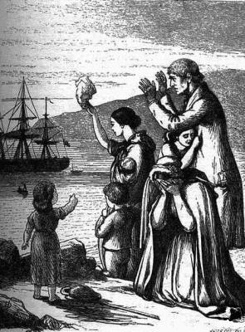
Credit: Wikipedia Commons Public Domain 'Emigrants Leave Ireland', engraving by Henry Doyle (1827–1892), from Mary Frances Cusack's Illustrated History of Ireland, 1868
1846 | The Leeds and Bradford Railway opened. Temple Street Methodist Church was opened (later ShahJalal Jami Masjid) Italian jeweller Antonio Fattorini opened his first shop in Bradford (much later the family became a major employer as Empire Stores).
1847 | Bradford was given a proper town council, run by a mayor, 14 aldermen and 42 counsellors. The first mayor of Bradford was Robert Milligan, a Scottish draper. The introduction of a local council eventually lead to improved water supplies, proper waste disposal of sewage, a police force to keep law and order, better houses for working people (although many slums stood for years) and impressive new buildings in the city.
1848-9 | 420 people died during a cholera epidemic.
1848 | Bradford was occupied by local soldiers to stop any trouble from the Chartists.
1849 | St Andrews Presbyterian Chapel (later Shiny Stars Day Nursery) was built for Scottish Presbyterians in Bradford.(Presbyterians are a kind of Protestant Christian).
1851 | Bradford’s population was 103,778. Around 10% of the people had been born in Ireland. 4,028 people attended Catholic services. There was anti-Catholic rioting in this year. Local textile manufacturer, Sir Titus Salt started to build a model village for his workers called Saltaire. He was one of several rich factory owners and business men in the second half of the nineteenth century who strongly believed in helping people, keen to improve the way Bradford`s ordinary working people lived.
1852-3 | Saint Patrick's Catholic Church, largely to serve the Irish Catholic community was built.  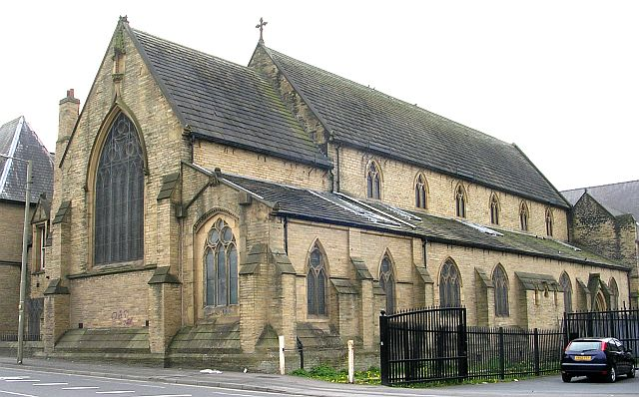  St Patrick`s Roman Catholic Church Credit; Wikipedia Commons Betty Longbottom
1853 | Salts Mill opened in the model village of Saltaire.
1850s | In the late 1850s fewer Irish people came to Bradford.. Clifton Villas (later homes to the Bradford Estonian and Latvian clubs) were built.
1861 | Bradford's population was 106,218. The Bedford Street area of Broomfield contained 1,162 people who were originally from Ireland or came from Irish families - 19% of the Irish population in the borough of Bradford.
1862 | The famous composer Julius Delius was born in Bradford. He came from a German family.
1864 | Charles Joseph Semon (1814 - 1877), a German Jew originally from Danzig (now Gdansk in Poland) became mayor of Bradford.  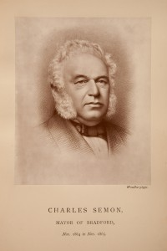  Credit: Bradford Council
1870 | The Chief Rabbi visited Bradford and tried but failed to form a Jewish Association. The wealthy Lister family sold their Manningham Park estate to Bradford Corporation to be used as a public park.
1871 | Bradford's population was 145,827. The Jewish community numbered between 200 and 300 people. According to the Jewish Chronicle Jewish services were held on special religious days days but only 30 to 40 Jews attended.
1872 | Famous Bradford artist William Rothenstein was born to a German Jewish merchant family.
1873 | The Jewish Association of Bradford was formed. Sion Baptist Chapel and Presbytery (later Gurdwara Amrit Parchar Dharmik Diwan, a Sikh Temple) was built. Westfield, a Victorian villa was built (later the Bradford Ukrainian Club).German Jewish merchant SL Behrens opened a large warehouse in the “Little Germany” district of Bradford.
1874 | The Belle Vue Hotel (later Minhaj-ul-Quran Mosque) was built.
1875 | St Mary`s Roman Catholic Church was rebuilt on its present site.
1876 | By this time the fine Victorian warehouses of Little Germany, largely built by German merchants was complete.
1878-9 | St Johns Methodist Church was built (later Most Holy Lady of Trinity and Our Lady of Pochaiv Ukrainian Roman Catholic Church).
1870s | A small number of Italians settled around the bottom of Otley Road, trading as ice cream and street sellers and street entertainers.
1880 | Bowland Street Reformed Synagogue in Manningham was opened. The Catholic Apostolic Church in Edmund Street was built (later Polish Parish Church).  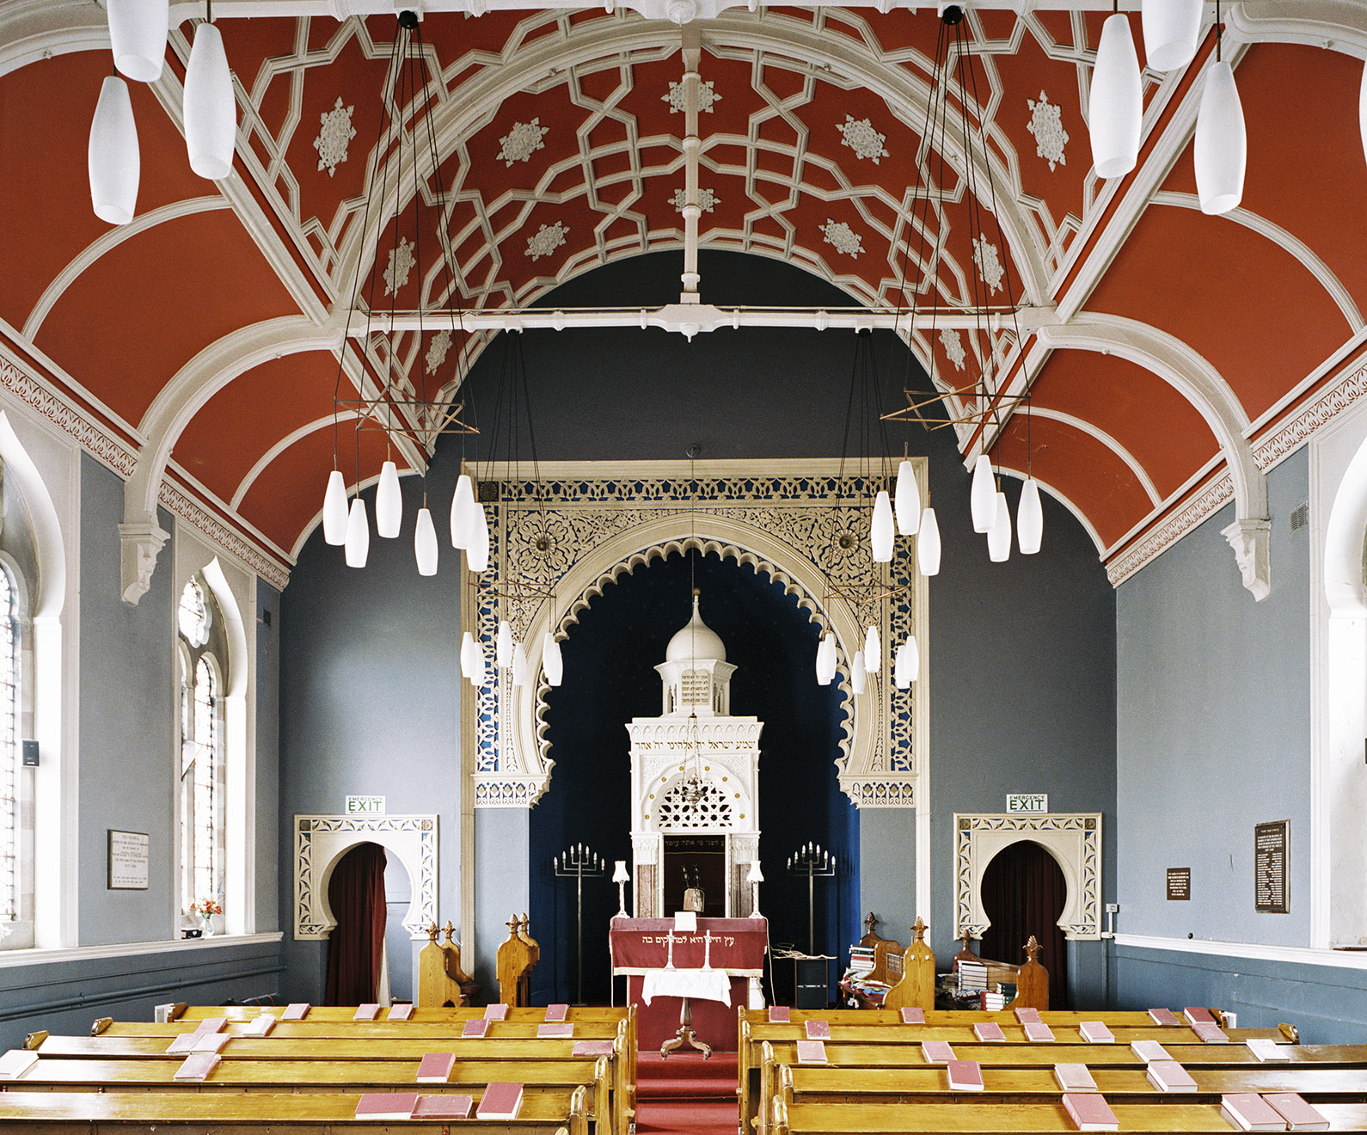  Bowland Street Reformed Synagogue © Historic England Archive – 16th October 2002. Ref: AA038929
1880s | A fresh wave of Jewish Orthodox refugees, fleeing persecution in Russia and Russian- ruled Poland settled in Bradford. They were unhappy with worship at the Bowland Street Reformed synagogue (it seemed very slack and was not strict enough for them).
1881 | Bradford’s population (including Bolton) was 183,032.
1881-96 | Local composer Julius Delius organised Bradford concerts attended by the Manchester Halle orchestra.
1886 | St Luke’s Church Hall was built (later Jamiat Tablighul Islam Mosque).
1887 | The General Post Office in Forster Square was built (later Kala Sangam, a South Asian arts centre).
1897 | Bradford became a city. German pork butchers from the Hohenlohe area of Baden-Wurtemburg in Southern Germany set up shops in Bradford in the late 19th and early 20th centuries.
1900 | The German Evangelical Church in Great Horton had more than 100 members.
1901 | Bradford’s population (including North Bierley, Tong, Thornton, Eclles Hill and Idle) was 279,767. Of 36 Bradford wool merchants, 23 were German. The New Beehive Inn was opened in Legrams Lane, partly to serve the needs of local Irish people who had been given new houses there.
1904 | The Cartwright Hall was opened. An industrial exhibition was held called the Great Bradford exhibition.
1905 | A Jewish Orthodox synagogue opened in Spring Gardens to serve the Jewish Orthodox community, unhappy with worship at the Jewish Reform Synagogue.
1906-7 | Richmond-Shearbridge Methodist Chapel was built (later Shearbridge Road Mosque).
1910-1 | Jacob Moser, a German Jew was elected Lord mayor of Bradford. He is said to have contributed £300,000 to charity in his lifetime.  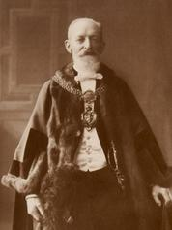  Jacob Moser Credit; Bradford Council
1911 | Bradford’s population was 288,458.
1913 | The Elite Cinema opened (later Jamiat Tablighul Islam Mosque).
1914 | August 4th Great Britain entered the First World War. Some young German residents in Bradford on the reserve list of the German army were seen off to Germany on trains by the pastor of the German Evangelical Church and a German band. German passport holders were imprisoned for the rest of the war if they did not return home by August 21st 1914. Germans who had become British citizens or men who came from German families sometimes served in the British Armed Forces. People think that half of the population of German Jews in Bradford changed their names during the war. This explains why people who may be descended from them cannot find out that their families may have been German and Jewish. There was less prejudice and violence directed against Germans in Bradford than in other parts of Great Britain.  In October 250 Belgian refugees arrived in Bradford, fleeing the German invasion of Belgium.  From 1914 to 1921 the German Evangelical Church was closed.  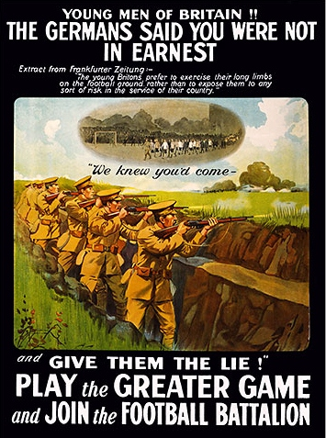  Credit: Wikipedia Commons Public Domain
1919 | Several hundred Belgian refugees left Bradford to return to Belgium.
1937 | 250 Basque children, evacuated from the Spanish Civil War settled in Bradford. They lived out their lives in the city.
1939 | No. 1 Parkfield Road (which later became the Carlton Hotel) was purchased to house 24 Jewish boys and one girl brought to Britain part of the Kindertransport, escaping Nazi persecution (the Nazi party controlled Germany and hated Jewish people). Many of their relatives afterwards died in the Holocaust when the Nazis murdered six million European Jews. Some other Jews escaping from the Nazis also found refuge in Bradford during the Second World War.  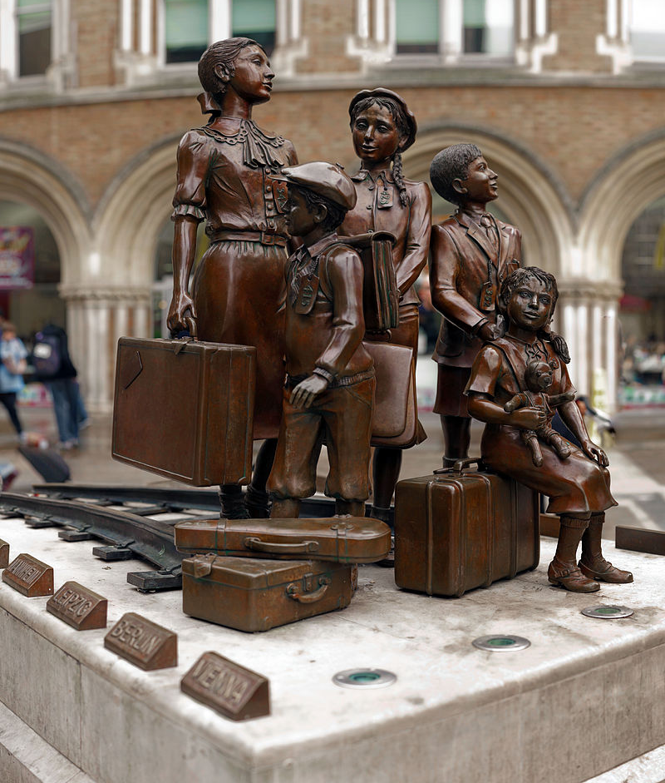  Modern statue commemorating the children of the Kindertransport Credit: Wikipedia Commons Wjh31
1941 | The first unemployed Indian Muslim ex-seamen (lascars) were directed to find jobs by the British government in Bradford. India (which at that time included modern Pakistan and Bangladesh) was controlled by the British and millions of Indians served in the Armed Forces and merchant ships during the Second World War against Germany and its allies.
1940s | In the late 1940s migrants settled in Bradford from Central and Eastern Europe. From 1947 European migrants were able to settle in Britain as part of the European Volunteer Workforce Scheme where they could only work in jobs where there was a shortage of people (such as in textile factories) for a period of three years.  There were around 4000 poles some of whom had been in the Polish Armed Forces in exile under British command during the Second World War and had been given permission to settle in the UK afterwards.  Some migrants were part of the U.K.'s international quota of displaced persons (people who had lost their original homes because of the war and could not return to where they came from). Many of them were former "Ostarbeitars" - Ukrainians, Poles, Czechs, Latvians, Estonians and Yugoslavians (including Serbs) taken from their homes and used as slave labour by the Nazis. Some Ukrainians had fought for the "Halychyna" division of the German Army on the Eastern Front. There were around 3400 Ukrainians settled in Bradford as a whole. In addition young women arrived from poor communities in Southern Italy.  In the late 1940s-1950s early South Asian migrants (from modern India, Pakistan and Bangladesh) to Bradford lived in low rent houses owned by Poles, near their work. South Asian Muslims generally worshiped together in private homes, whatever type of Muslim they were and wherever they came from. They were mostly men who did not send for their families to join them as yet
1950 | There was still 1123 Wool and Worsted mills open in Bradford.
1953 | Around 35,000 people in Bradford were Catholics. One in nine of the population. Most of these were from Irish families who came in the nineteenth century.
1955 | No. 5 Clifton Villas became the base of Bradford Latvian Club.
1956 | No. 8 Clifton Villas became the base of Bradford Estonian Club. Around 2,000 Hungarians started settling in Bradford, fleeing an unsuccessful rebellion against Soviet (Russian Communist) occupation. They established a Hungarian Cultural and Social Centre at No. 4 Walmer Villas.
1959 | Pakistanis owned two grocery/butchers shops and three cafes in Bradford.  Bradford's first mosque opened in Howard Street.
1960s | South Asian workers helped to keep textile mills running at a time when most people could get jobs. Despite this they faced racist prejudice and discrimination.
1962 | The Commonwealth Immigration Act restricted migration to Britain from the Commonwealth (the countries of the old British Empire such as India and Pakistan). The new law encouraged migrant workers to settle in Bradford before the new rules became law.
1964 | Bradford had a population of 12,000 Pakistanis, 5400 from Mirpur, 3000 from Chachh in Campbellpore District on the Punjab/North West Frontier Province border, 1,800 from Punjab and 1,500 from East Pakistan (from 1971 Bangladesh. In the 1960s and 1970s South Asian migrants decided that they would stay in Bradford and sent for their families to live with them. West Indian families also settled, around half from Dominica but also from Jamaica, Barbados and other Caribbean islands.
1966 | There were 133 Pakistani businesses in Bradford including 51 grocery/butchers shops and 16 cafes.
1967 | There were 825 wool and worsted mills open in Bradford.
1970 | There were 260 Pakistani businesses including 112 grocery/butchers shops and 25 cafes. The former Jewish Orthodox Synagogue in Spring Garden was closed and the congregation moved to Shipley.
1971 | Bradford’s population was 294,164. Through the 1970s Bradford became poorer and lots of people could not find jobs.
1972 | Bradford`s first purpose built Gurdwara (Sikh temple) opened in Malvern Street (Guru Gobind Singh Gurdwara).
1975 | Shearbridge Road Methodist Church re-opened as Shearbridge Road Mosque.
1976 | In April 24 people were arrested during some violence in Manningham where Asian and West Indian youths tried to stop a National Front march. It became known as “the battle of Bradford”.
1978 | Annesley Methodist Church in Little Horton Lane re-opened as the Serbian Orthodox Church of the Holy Trinity.
1981 | Over the previous three years 16,000 textile and engineering workers in Bradford had lost their jobs. Loss of jobs and poverty meant relations between different groups of people in Bradford became difficult. The former Temple Street Methodist Church re-opened as the ShahJahal Jamiah and Quaraniah Masjid.
1985 | The Italian Catholic Mission moved in to 68, Little Horton Lane.
1985-6 | Mommmed Ajeeb became Bradford’s first Asian Lord Mayor. The former Elite Cinema became the Jamiyat Tabligh-Ul-Islam mosque.
1980s | Bradford settled Vietnamese people rescued from boats at sea fleeing their homeland.
1997 | The Mughal Gardens were opened in Lister Park as a tribute to Bradford’s links with South Asia.(The Mughals were a family of Muslims who ruled India before the British).
1999 | Bradford Central Mosque (Jamiyat Tabligh-ul-Islam) was opened – the first purpose built mosque in Bradford.
2001 | Bradford`s population was 467,665. There were 85,565 people of Pakistani, Indian and Bangladeshi origin in all. Of these 67,944 were of Pakistani origin, 12,604 of Indian origin and 4,967 of Bangladeshi origin.  Those of Pakistani origin made up 14.5% of the population Of Bradford as a whole.
2003 | The former Orthodox Jewish Synagogue in Spring Gardens opened as the Al Mumin Primary School (a private Muslim school).
2004 | European Union citizens from the following countries were allowed to work and settle in the UK, including Bradford. (Czech Republic, Estonia, Hungary, Latvia, Lithuania, Poland, Slovakia, Slovenia, Malta and Cyprus).
2007 | European Union citizens from Rumania and Bulgaria were allowed to work and settle in the UK, including Bradford.
2008 | There were only four woollen and worsted mills left open in Bradford. Bradford groups, including faith groups established the city as a “City of Sanctuary”, working to provide welcome and support for those seeking asylum and with refugee status.(People escaping persecution or danger in their home countries can ask for permission to stay in Britain “asylum” – sanctuary means a safe place). The Al Mahdi Mosque for local Ahmadi Muslims was opened.
2010 | The Hungarian Cultural and Social Centre closed. The German Evangelical Church re-opened as the Delius Cultural Centre although services were still held there.
2011 | Bradford’s population was 522,452, of which 26.83% were Asian and 24.7% were Muslims. There were 8,335 employed EU migrants. Polish was spoken by 5526 residents, making it the fourth most used language in Bradford.
2012-3 | The Salahadin Mosque was built and opened by the West Yorkshire Kurdish Association.
2013 | Some Bradford Muslims contributed funds to repair and keep open the remaining Jewish synagogue in Bowland Street, Manningham.
2015 | A group of Bradford Muslim women launched a campaign for a new mosque to be built to be entirely controlled by women.
2016 | 158 Syrian refugees had been settled in Bradford under the UK government’s commitment to offer sanctuary to Syrians displaced in Middle Eastern refugee camps by the Syrian civil war. This was a high proportion of the total number of such refugees admitted to the UK as a whole.
2017 | There were around 90 mosques operating across Bradford. Checkpoint, the Bradford West Indian Centre closed.

This timeline relates to the activities that are part of the Shearbridge Road Mosque Case Study ‘https://historicengland.org.uk/services-skills/education/teaching-activities/stories-in-stone-shearbridge-mosque’

