Episode 4: A visit from the King
In this episode you might come across some new words. Here are some we thought were interesting:
Façade – the principal front of a building, which faces onto a street or open space
Gable end – the triangular upper part of a wall at the end of a ridged roof
Ironmonger – a person or shop selling hardware such as tools and household implements

As you are listening:

Jot down things you find interesting…

What types of shops are mentioned in this episode?

Discuss your answers as a class.

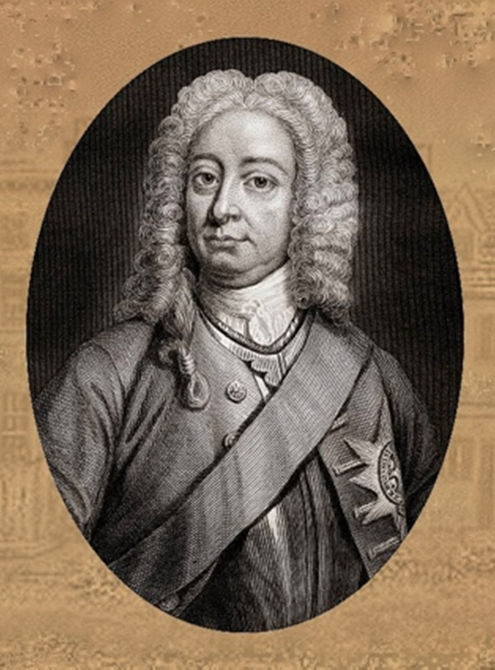
King George II
King George II stayed one night in the High Street in Lowestoft when storms forced his boat ashore in the town.
If the King visited Lowestoft today, what would he say and do?
Below are five questions to help you write a poem about his visit. Answer them in a sentence — no one word answers! — and by putting your responses together, line-by-line, create a poem about the King coming to Lowestoft.
The title of your poem is 'When the King came to Lowestoft’

1) How did he arrive — He arrived in a sport car over the bridge.
2) Who would he meet — The King met Ed Sheeran and sang a song with him.
3) What did he say — The King said...
4) How did he leave? — The King's speedboat arrived and...

Example:
When the King came to Lowestoft
He arrived in a sports car over the bridge
© Jack Rose Collection
He met Ed Sheeran and sang a song with him.
The King said, Lowestoft has the best fish and chips
His helicopter arrived and flew him away into the clouds.
Put your responses together, line-by-line, create a poem about the King’s visit.

He arrived in ........

He met.......

The King said......

The King's ………………….. arrived and............

