Episode 8: Around The Globe
In this episode you might come across some new words. Here are some we thought were interesting:
Provisions – an amount or thing supplied or provided. For example, food and drink provisions or equipment

As you are listening:

Jot down things you find interesting…

What types of shops are mentioned in this episode?

Discuss your answers as a class.
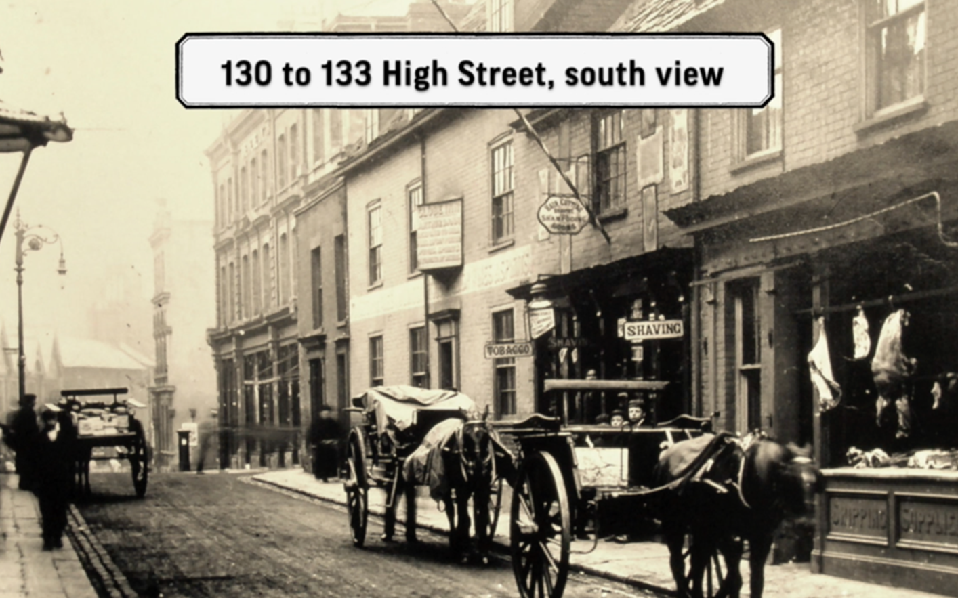
Lowestoft's High Street in the 1890s
© Jack Rose Collection

Photographs give us a chance to time travel, looking at how we lived in the past.
What things can you see?

What can you spot in the shop windows?

We’re going on a scavenger hunt in this photo to make a list poem with the answers we find using five prompts.
- Where are you?
- What do you see in the street?
- Can you find something there is more than one of?
- Can you imagine a colour that might be in the photograph?
- Can you imagine a noise you might hear on that street?

Find the following and write a sentence about each of them and build a poem line by line, giving examples as you go.

1.

2.

3.

4.

5.

Example:
In This Street
I'm walking down the High Street in 1891
There's a post-box to post a letter to my great great great grandfather
I could be friends with the two boys
The boy has a blue cap, which he'll lose later that afternoon
I can hear footsteps behind me; my friend calls my name

