Episode 9: The Tailor and The Chemist
In this episode you might come across some new words. Here are some we thought were interesting:
Temperance Pub – Temperance pubs and bars were a type of pub in the late 19th and early 20th centuries. They did not serve alcohol; instead they sold non-alcoholic drinks such as cream soda and dandelion and burdock
Tailor – a person whose job is to cut or style clothes, such as coats or suits
Seamstress – a woman who sews and makes clothes

As you are listening:
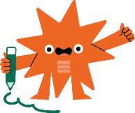
Jot down things you find interesting…

What types of shops are mentioned in this episode?

Discuss your answers as a class.
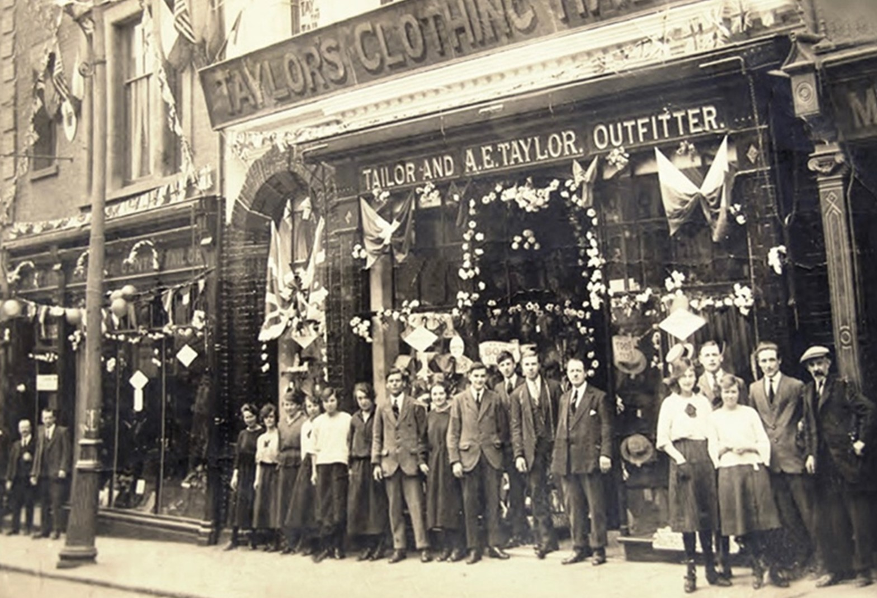
Taylor’s clothing store on Lowestoft's High Street in the 1920s
© Ivan Bunn Collection

Think of a favourite item of clothing, either in the past or something you have now

You’re going to use your favourite item to make a list poem with the answers we find using five prompts.
- What is it? That’s your title – e.g. My Cosy Blue Hoodie
- Where did you get it from and why you got it? e.g. I got it for Christmas from my mum
- Describe a detail about it? e.g. It’s got a pocket at the front where I keep my phone, sweets and keep my hands warm!
- Somewhere you've worn or wear it? e.g. I wear it curled up on the couch
- Something that happened when you wore it / or the last time you wore it? e.g. I spilt my dinner down it and it was ruined!

Use your answers to build your poem.

Title.

Example:
My Cosy Hoodie
I got it for Christmas from my mum
It's got a pocket at the front where I keep my phone, sweets, tissues and keep my hands warm.
I wear it curled up on the couch
I spilt my dinner down it and it was ruined!

