The Victorians built many buildings; every town has buildings from the Victorian period

Buildings are built by people, for people and are designed with specific purposes in mind. The Victorians had strong views that are reflected in their buildings.

You can find more background in the Information Sheet ‘What can Victorian buildings tell us about how the Victorians thought?’ relating to;
- The growth of towns
- Victorian beliefs and attitudes
- Which documentary sources can help you to find out more about Victorian buildings

Card Sort Activity
This card sort can be used to introduce the idea of why buildings were built – what motivated the person or people who built them.

How to use the card sort

- Cut out the images of buildings and the pieces of text giving possible motives for building
- Ask students in pairs to match the motives to the images
- Make it clear that there can be several motives associated with each building – and that some motives will apply to more than one building.
- Ask each pair to talk about one building explaining why they decided on the motives they chose
- Discussion
  - Did all the students choose the same motives, if not why not?
  - Is it always possible to work out the motives from the actual building?
  - If not what documentary evidence can be used to find more detailed information?

See also

The Image by theme – Victorian Buildings has more information about all of the buildings used in the card sort.

This activity is related to the Teaching Activity: What can Victorian buildings tell us about how the Victorians thought?

To make life better for people | To control people
To make a product | To make people safer
To impress people | To encourage self-improvement
To intimidate people | To look beautiful
To look democratic | To look solid and respectable
To encourage commerce | To store products
To promote cleanliness and good health | To create a dependable workforce
To show off your wealth | To educate people
To leave a legacy of your life | To improve moral standards
To improve the environment | To inspire people

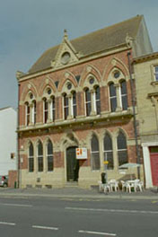  Museum and Public Library, Fleetwood, Lancashire | 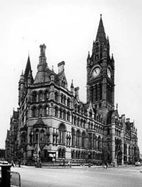  Town Hall, Albert Square, Manchester
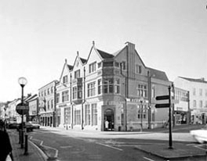  Midland Bank, Oswestry, Shropshire | 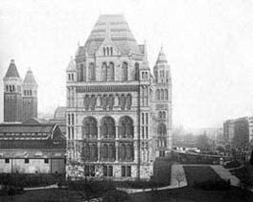  The Natural History Museum, Greater London
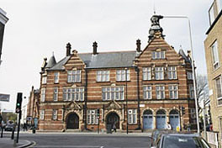  St Pancras Public Baths, Camden, Greater London | 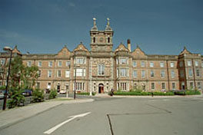  Workhouse (now St James Hospital), Leeds, Yorkshire
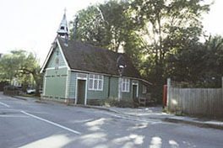  Old Fire Station, Shere, Surrey | 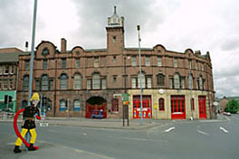  West Bar Old Fire Station, Sheffield, Yorkshire
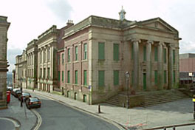  Oldham Town Hall, Greater Manchester | 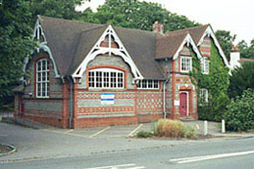  Old School and School House, Shinfield, Hampshire
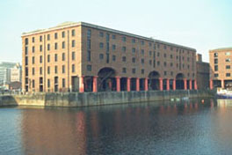  Warehouse D, Albert Dock, Canning Place, Liverpool | 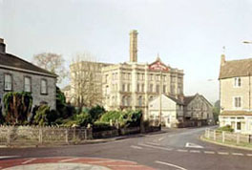  Anglo-Bavarian Brewery, Shepton Mallet, Somerset

