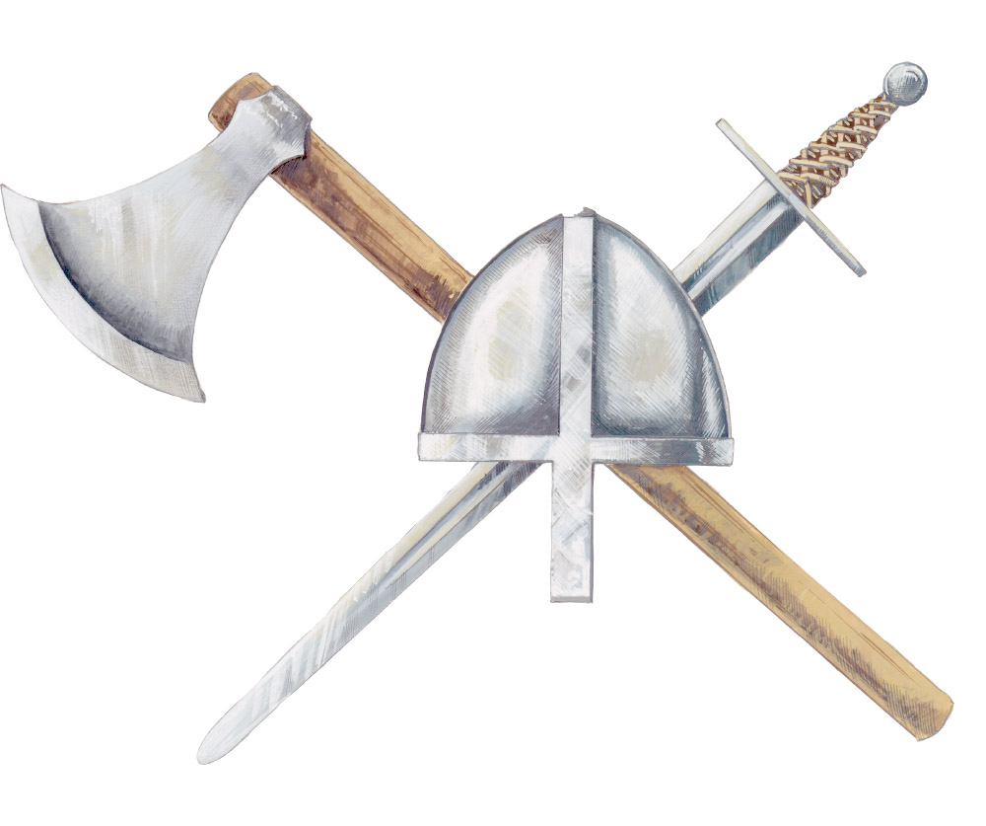 | We can find out lots about the  Anglo-Saxons by looking at archaeological evidence

It's an archaeologist’s job to look at evidence, such as artefacts and buildings, from the past and to try and interpret them!

Could YOU be an archaeologist?

Step 1:
Learn to speak ‘archaeologist’
To be an archaeologist you need to learn some new words
Archaeology:
The study of the lives of people in the past

Evidence:
Information to support an idea/interpretation

Artefact:
Any object made or changed by people

Interpret:
To try and explain what something means

Excavate: To dig up and record archaeological remains

Step 2:
Rot or Not?
Look at all the things below. Which do you think would survive being buried in the ground for 1000 years?

Food

Pottery

Metal

Glass

Wood

Fabric

Bones

Leather

Cut out the pictures and stick them onto the chart on the next page to show your choices
Rot  Would not survive 1,000 years | Not  Would survive 1,000 years

How did you do?
Rot  Would not survive 1,000 years |  | Not  Would survive 1,000 years
Food  Wood  Fabric  Leather |  | Pottery  Metal  Glass  Bones
 | Step 3:
Find EVIDENCE from the past
Archaeologists EXCAVATE (dig up) archaeological sites to discover and record daily life in ancient times

The photograph below shows ARTEFACTS from an EXCAVATION in Wheatley in Oxfordshire that took place in 1890

Can you work out what any of the ARTEFACTS are?
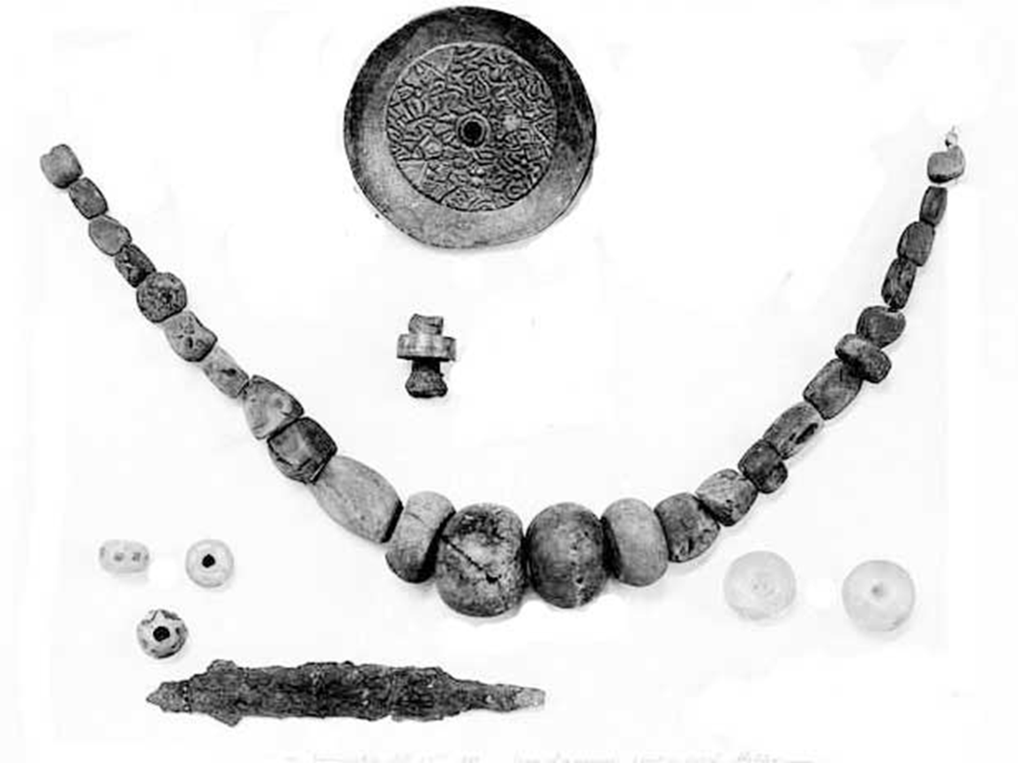
How did you do?

Brooch
(Metal)

Necklace
(Pottery beads)

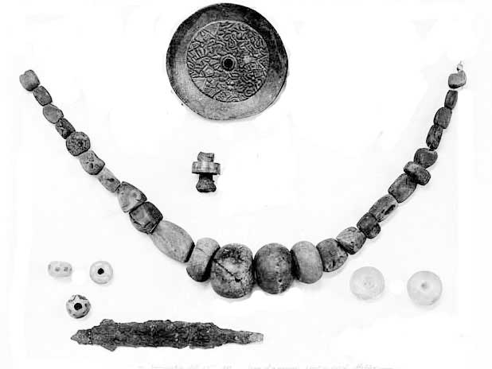

Ring
(Metal)

Finger bone!
Knife blade
(Metal)

Beads
(Glass)

Beads
(Glass)

Step 4:
INTERPRET EVIDENCE from the past
Artefacts need to be interpreted. Archaeologists often do this by creating a RECONSTRUCTION DRAWING
What you know | What you don’t know/need to find out
Wore a necklace | A man or a woman?
Wore a brooch | What type of clothes?
Wore a ring | What colour clothes?
Carried a small knife | Long hair or short?

Anglo-Saxons mainly had wool or animal skins to make clothes

Anglo-Saxons only had natural dyes
Use your evidence to draw what you think the Anglo-Saxon owner would have looked like!
Remember to think about……………….
Now look at a friend’s drawing - does it look the same as or different from yours?

Ask them to explain what they drew and why.
Remember
All of your drawings - no matter how different - are proper archaeological interpretations, so long as you used the evidence to justify what you drew and why!

Need some inspiration? This is a reconstruction drawing of what an Anglo-Saxon man and woman might have looked like.

