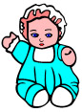 The doll is the same as dolls today because:
…………………………………………
…………………………………………
The doll is different from dolls today because:
…………………………………………
…………………………………………

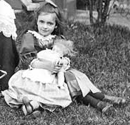

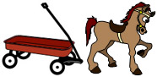 The horse & cart is the same as toys today because:
…………………………………………
…………………………………………
The horse & cart is different from toys today because:
…………………………………………
…………………………………………

…………………………………………

