Step 1: Look at the photograph of York Castle. Castles were introduced to England, along with the Feudal System, by the French after the Norman Conquest of 1066. A castle was first built on this site by William the Conqueror in 1068-9.

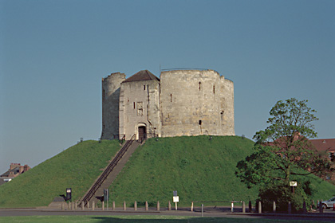
© Mr Martin Roberts. Source Historic England Archive

Step 2: Think about the different ways in which a castle could help William keep control over his new kingdom. Write a list of these different ways – you should split your list in to two categories, as in the table below. (N.B: Need some help getting started? Look at the hint after Step 6)

The PHYSICAL effects of castles | The PSYCHOLOGICAL effects of castles

Step 3: Now use the Images by Theme on Castles to select another different castle for each of your
reasons, explaining why you have chosen it. Copy and paste the thumbnail of the image into the
table below.

Reason No. | Thumbnail  of castle | This castle represents this reason because………
1
2
3
4
5
6

Step 4: Using your list of reasons and example castles write a short paragraph answering the
question
How did William the Conqueror secure his position after the conquest of 1066?

Hint: Castles………….
Protected the Norman lord

Intimidated people
Constantly reminded people who was in charge
Provided work for local people
Deterred people from attacking the Norman Lord
Altered the local landscape

Provided a place to keep soldiers

Destroyed parts of some existing towns and villages

Extension Work

Step 5: Were castles William’s only way of securing power? Use the ‘student notes’ provided on the
next page to discover more about castles and William’s way of ruling England.

Step 6: Having discovered more about William’s rule discuss the question:
Would William have been so successful if he had just built castles and not brought over his own nobles and the Feudal System?

This activity relates to the Teaching Activity: How did William the Conqueror secure his control over Saxon England?

Student Notes: Castles and the Norman Conquest

- A castle is defined as a fortified residence belonging to nobility. The first castles were built in France in the 10th century (900s)

- William was crowned King of England on 25th December 1066 at Westminster Abbey, after defeating King Harold at the Battle of Hastings. This marked the start of Norman rule in England which lasted for nearly 100 years

- The Normans imposed several major changes on the Anglo-Saxon way of life. The most notable were the introduction of Castles, the Feudal System and French as the official language at court

- William gained security in England by granting areas of land to trusted Norman nobles, who in return had to perform certain duties such as building and defending castles and providing knights for the king. This was all part of the Feudal System (see below)

- To begin most English castles were made from earthworks (mounds of soil/earth) and timber buildings. The most common type was motte-and-bailey castles consisting of an enclosure (the bailey) with a mound of earth (motte) with its own ditch around the base. On top of the motte was a wooden palisade (large fence) with a wooden tower (later referred to as the keep) and other buildings inside. There would have been a wooden bridge over the ditch to connect the motte to the bailey.

- The 12th century (1100s) saw many of these wooden towers and palisades rebuilt in stone. It is these stone towers and (curtain) walls that are left for us to see today

The Feudal System

The King owned all the land. He granted land to:

Tenants-in-chief (Barons and Bishops), who in return swore an oath of loyalty to the king. They agreed to build castles and provide knights for his army. The tenants-in-chief in turn granted land to:
Knights, who in return swore an oath of loyalty to them and promised to fight for the king’s army for 40 days a year. The knights in turn granted land to:

Peasants, who in return swore an oath of loyalty to them and had to provide free labour, food and services for the knight

