If I was going on a picnic today I would eat and drink:
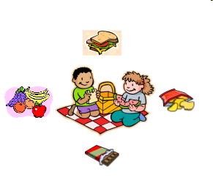 | - _ _ _ _ _ _ _ _ _ _ _ _ _ _ _ _ _ _ _ _ _ _ _ _  - _ _ _ _ _ _ _ _ _ _ _ _ _ _ _ _ _ _ _ _ _ _ _ _  - _ _ _ _ _ _ _ _ _ _ _ _ _ _ _ _ _ _ _ _ _ _ _ _  - _ _ _ _ _ _ _ _ _ _ _ _ _ _ _ _ _ _ _ _ _ _ _ _  - _ _ _ _ _ _ _ _ _ _ _ _ _ _ _ _ _ _ _ _ _ _ _ _

If I was going on a picnic 100 years I would eat and drink:
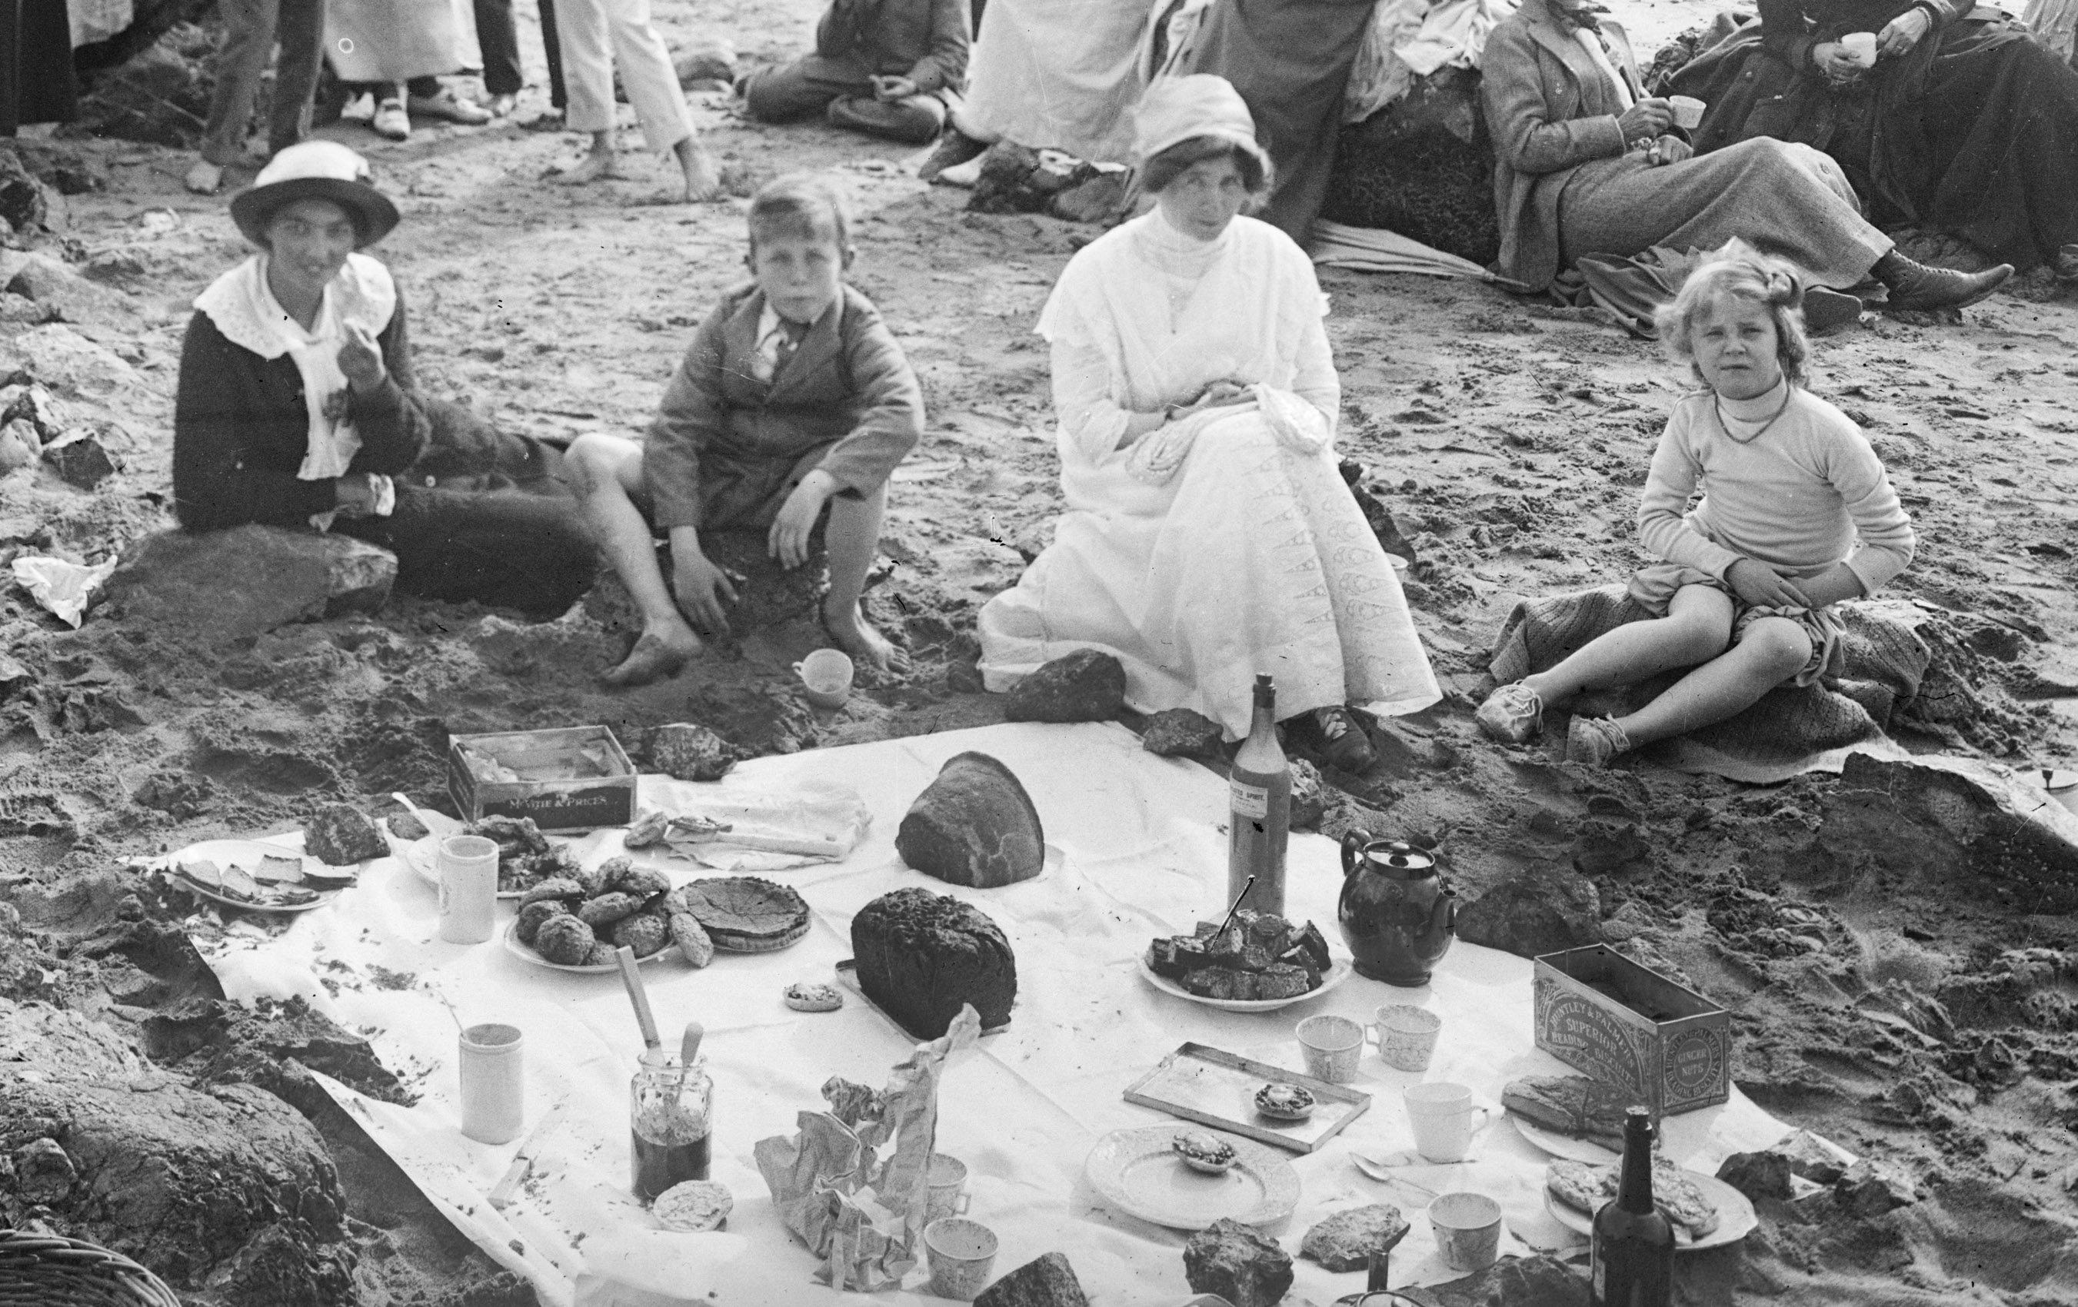 | - _ _ _ _ _ _ _ _ _ _ _ _ _ _ _ _ _ _ _ _ _ _ _  - _ _ _ _ _ _ _ _ _ _ _ _ _ _ _ _ _ _ _ _ _ _ _  - _ _ _ _ _ _ _ _ _ _ _ _ _ _ _ _ _ _ _ _ _ _ _  - _ _ _ _ _ _ _ _ _ _ _ _ _ _ _ _ _ _ _ _ _ _ _  - _ _ _ _ _ _ _ _ _ _ _ _ _ _ _ _ _ _ _ _ _ _ _

This worksheet is designed to accompany the KS1 Power Point:
‘What can we learn about food in the past from a photograph of a seaside picnic?’

