Can you work out what these symbols mean?
Throughout history people have communicated by drawing pictures or symbols instead of using words to get their message across. In pairs or groups try to ‘read’ each of these symbols and write down what you think it means.
 | 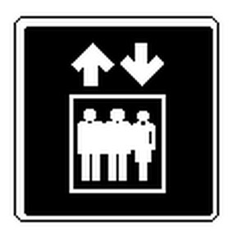 | 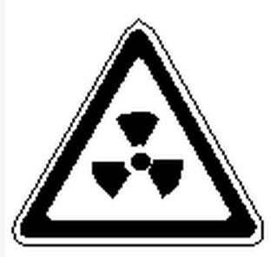
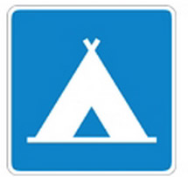 |  | 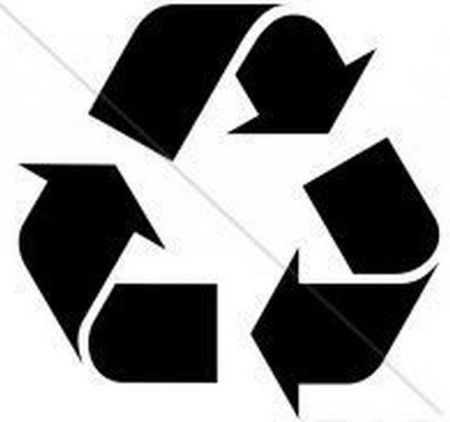
 |  | 
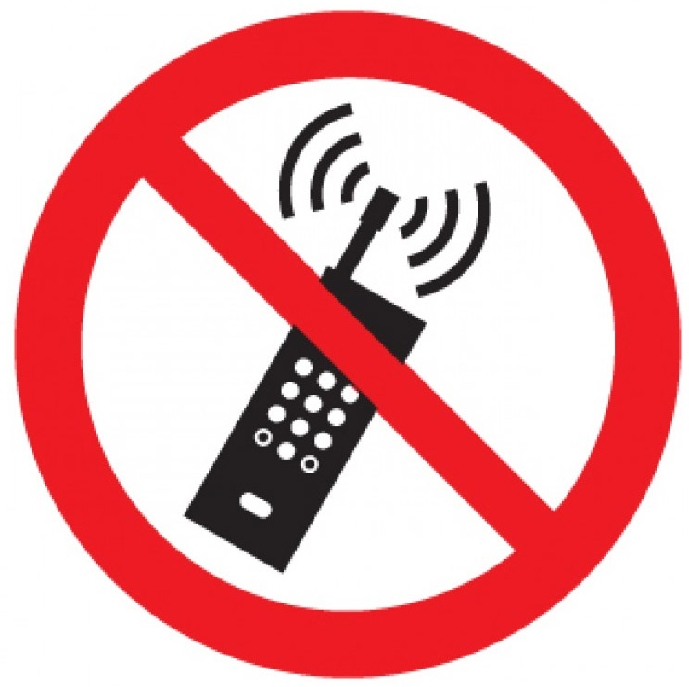 |  | 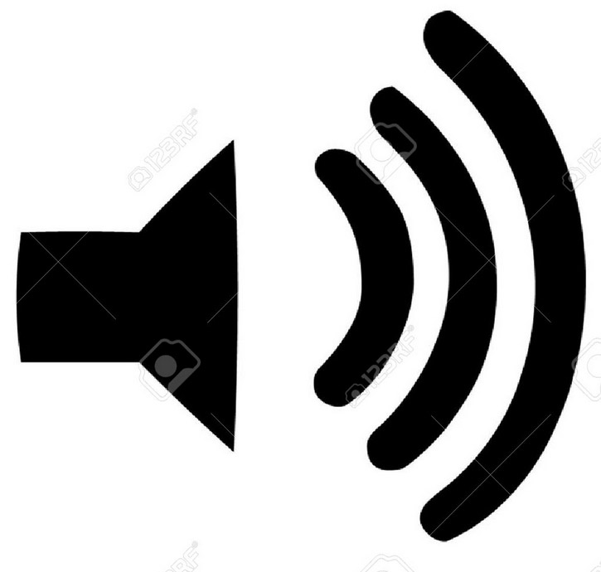

What about these too!

This worksheet is intended to be used with the Teaching Activity: Prehistoric Rock Art: Make you own Rock Art. The answers to this quiz are in the PowerPoint Prehistoric Rock Art: Make your own Rock Art

