Fill in the chart using the information from the captions in the Images by Theme called Victorian Buildings.

Building | Why it was built | What it tells us about the Victorians
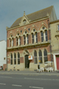
Museum and Public Library, Fleetwood, Lancashire
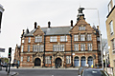

St Pancras Public Baths, Camden, Greater London
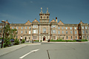
Workhouse (now St James Hospital), Leeds, Yorkshire

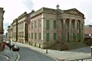
Oldham Town Hall, Greater Manchester

West Bar Fire Station Museum, Sheffield, Yorkshire
Old Fire Station, Shere, Surrey
Old School House, Shinfield, Hampshire
Albert Dock, Canning Place, Liverpool

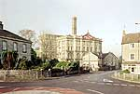
Anglo-Bavarian Brewery, Shepton Mallet, Somerset
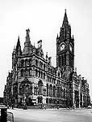
Town Hall, Albert Square, Manchester
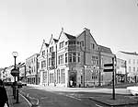
Midland Bank, Oswestry, Shropshire
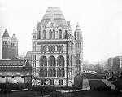
Victoria and Albert Museum, Greater London

Use the information in your chart to make a list of five things that you have learned about the Victorians from studying their buildings.
This card sort relates to the Teaching Activity: What can Victorian buildings tell us about how the Victorians thought?

